GREEN: Punnet Squares
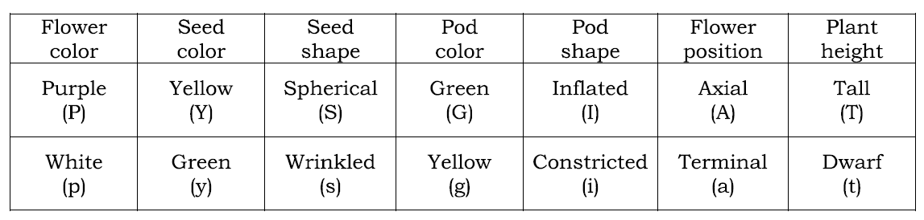
Below are all the possible attributes for a particular species of plant. The capital letters means it is dominant and a small letter means it is recessive.
- Draw a punnet square for each of these crosses to show all the possible offspring.

  - GG x Gg
G
g
  - aa x Aa
  - Ss x Ss
  - yy x yy
- Using a punnet square for PP x pp, calculate the probability that the offspring plants will be purple? How many will be white?
- tt x Tt
- Draw a punnet square.
- What is the probability that the plant will be tall? What about dwarf?

AMBER: Harry Potter Genetic Probability
From: ANolan
- If Alice Dudley has alleles Mm and she marries John Smith who has alleles MM, draw a punnet square to show all the possible children then could have. Could they have a child who is a wizard?
- What if Alice Dudley (Mm) decides to get married to Ron Weasley (mm), what is the probability that one of their children will be a wizard? Draw a punnet square to show your answer.
- What is the probability that Clara and Daniel May have children that are wizards if they both have alleles Mm?
- What is the probability that Harry Potter and Ginny Weasley have children that do not have any magical ability? What is the probability that they have children that are wizards?

RED: Simpsons Genetic Probability
(Adapted from: https://www.google.co.uk/url?sa=t&rct=j&q=&esrc=s&source=web&cd=4&cad=rja&ved=0CEYQFjAD&url=http%3A%2F%2Fwww.schurzhs.org%2Fourpages%2Fauto%2F2010%2F12%2F20%2F64197342%2FSimpsons%2520Genetics.doc&ei=C6vaUYj6A8PKhAeztIHIDw&usg=AFQjCNEa-pXgggJc8Gsx56YOZspwq-c0Pw&sig2=PC_Umgto2jN7zW35YqGSOA&bvm=bv.48705608,d.ZG4)
Problem One: Incomplete Dominance
Homer has decided he wants to go into the dog breeding business and wants to use Santa’s Little Helper. Santa’s Little Helper is heterozygous light brown (Bb), a combination of dark brown (B) and white (b). Homer wants to get puppies that are dark brown, light brown and white and has two choices of dogs he can mate with Santa’s Little Helper: Penelope, who is also light brown (Bb) or Samantha, who is white (bb). Create Punnett Squares for each dog to help Homer figure out the answer.
Penelope Samantha


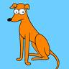

- Which dog would be best to mate with Santa’s Little Helper to get the most different coloured puppies?
- What is the probability that a puppy that Samantha gives birth to be will be white?
- What is the probability that a puppy that Penelope gives birth to is brown (light OR brown)?
- If Samantha had 10 puppies, how many of them would you expect to be dark brown? How about light brown?
- What is the probability that Santa’s Little Helper will have a puppy just like him, with either Penelope or Samantha?

Problem Two: Codominance
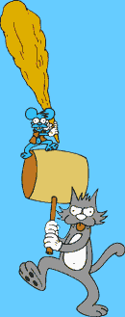
Itchy and Scratchy created two brand new breeds of flowers: one lime green (GG) and one bright orange (OO). Green is codominant (equally dominant) with orange. Itchy and Scratchy know that because of codominance, if they cross these two plants, the flowers should be both green and orange.
- Complete the Punnett Square

Itchy & Scratchy

- What is the probability that one of the new plants grown will be green (GG)?
- If they cross these two plants, how many will be both green and orange if they grow ten plants?
4. How many out of 10 will be orange?

Problem Three: Sex-linked Traits
Dr. Hibbert is treating a young Springfield couple who are having a child. The parents are worried that since the mom is a carrier for the disorder of colour blindness (XX^{c} ), which is linked only to the female sex chromosome X^{c} , that the child will have colour blindness as well. The father does not have colour blindness (XY) which is the dominant gene. What are the odds that the child will NOT have colour blindness?

X = no colour blindness (dominant)

X^{c} = colour blindness (recessive)

- What are the odds that their child will not be colour blind?

Problem Four: Worded Question
- If one parent has two dominant alleles for ear lobes and one has two recessive alleles for ear lobes, calculate the probabilities for the ear lobes of their possible offspring and write the results as a ratio.

